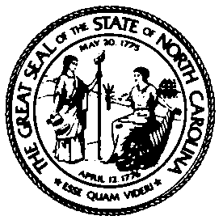
Forensic Tests for Alcohol Branch, DHHS
Electronics Laboratory
Phone: (919) 707-5259 or (919) 707-5260
FAX: (919) 870-4814

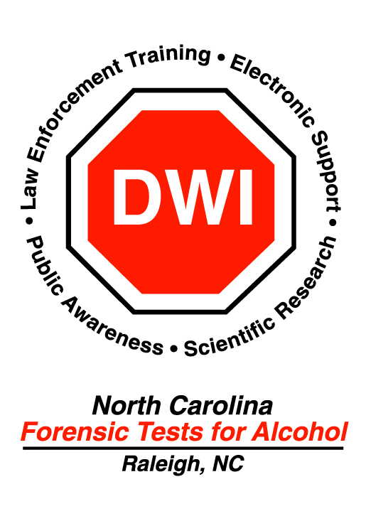

Date: | Device : Make / Model | Serial Number

Agency Name | Address / Location | Contact Person & Telephone

Please give SPECIFIC description of Problem / Malfunction:

To Be Completed by FTA Electronics Laboratory ONLY!
Repairs / Comments:

Note: If sending by US Postal Services, mail to: Forensic Tests for Alcohol, 1922 Mail Service Center,
Raleigh, NC 27699-1922
Attn: Electronics Laboratory

If by UPS send to: Forensic Tests for Alcohol, Electronics Laboratory LL2, 5505 Six Forks Road, Raleigh, NC 27609-3809

Date Received: Received By:

Date Returned: Returned By:

